**NANYANG TECHNOLOGICAL UNIVERSITY**

**SCHOOL OF COMPUTER SCIENCE AND ENGINEERING**



**INTERIM REPORT FOR FINAL YEAR PROJECT**

**A Final Year Project submitted to the School of Computer Science and Engineering,**

**Nanyang Technological University in partial fulfilment   
of the requirements for the Degree of Bachelor of Computer Science**

**Year of Publication: 2020**

**Background**   
According to LinkedIn statistic, the percentage of women in technology line are rather small.

“If you live and work in Silicon Valley one thing has been obvious for a long time. When you walk in to any tech company office, the male software engineers dramatically outnumber their female counterparts. Now we have the numbers to prove it - and it turns out that this trend applies worldwide, not only to the Valley.

We dug into LinkedIn data to see what percentage of women work in software engineering across industries. Whatever industry you look at, the number of female engineers is bleak.”

<https://business.linkedin.com/talent-solutions/blog/2014/03/women-in-engineering-the-sobering-stats>  
  
**Objectives**

* Raise awareness of the things that computer engineer does to attract girls to enjoy such tasks

**Scope**

An interactive game that teach young girls to code. The game must be available in a website.

**Progress**

1. Created the sprite sheets of characters.

* Duration: 2-3 months (have to learn from the scratch and I have no artistic skills)

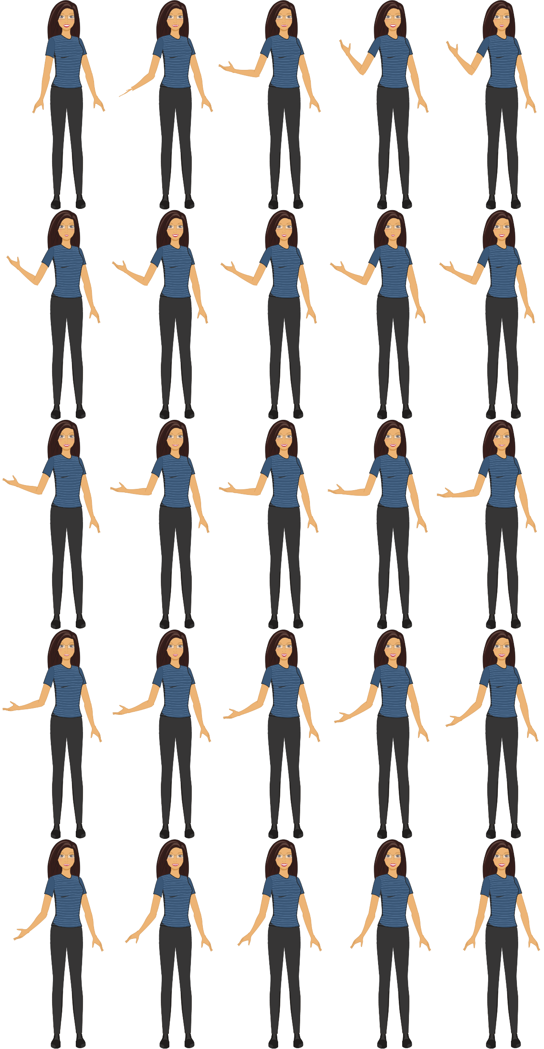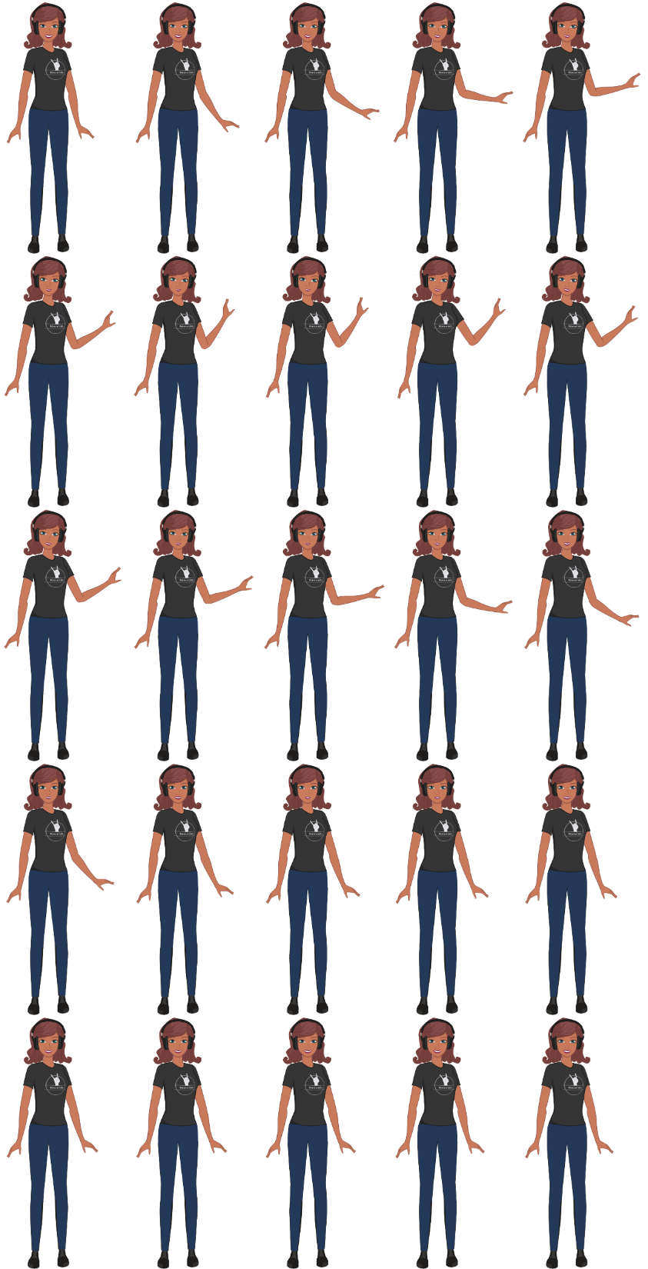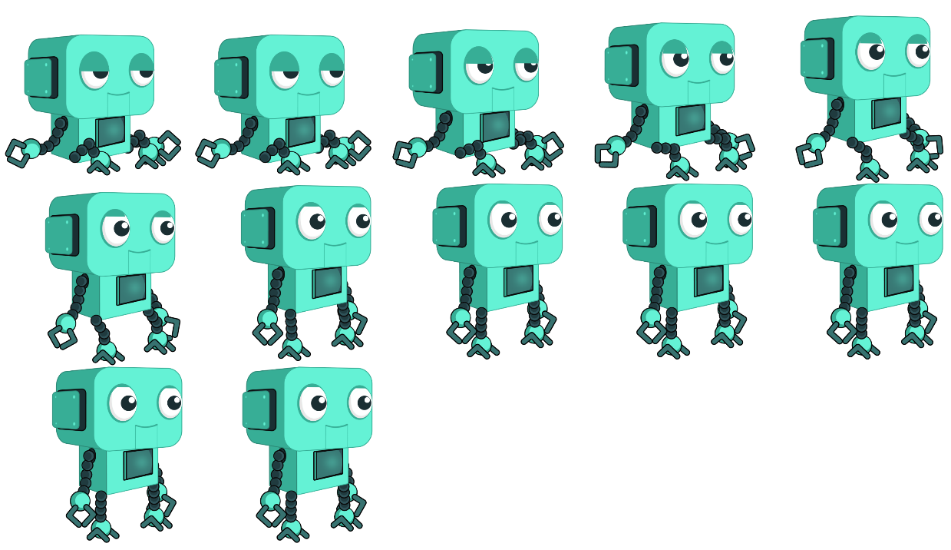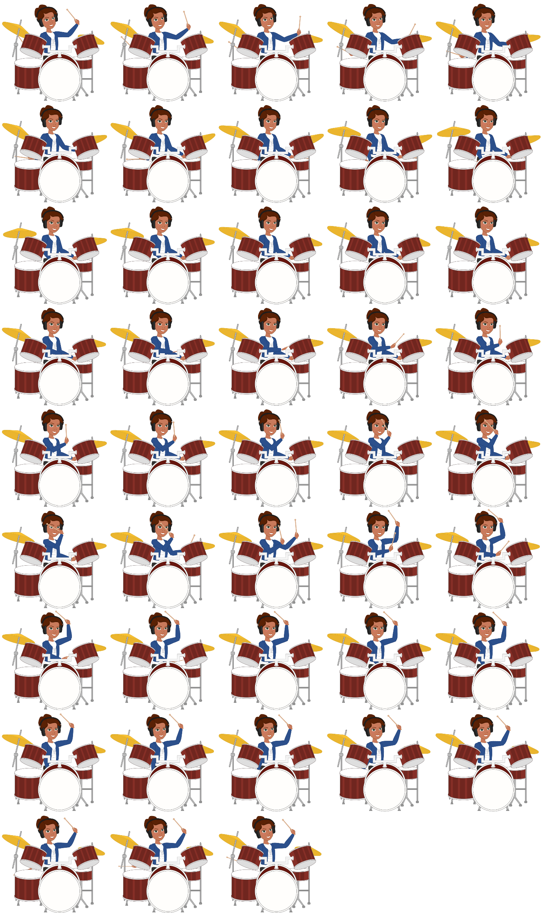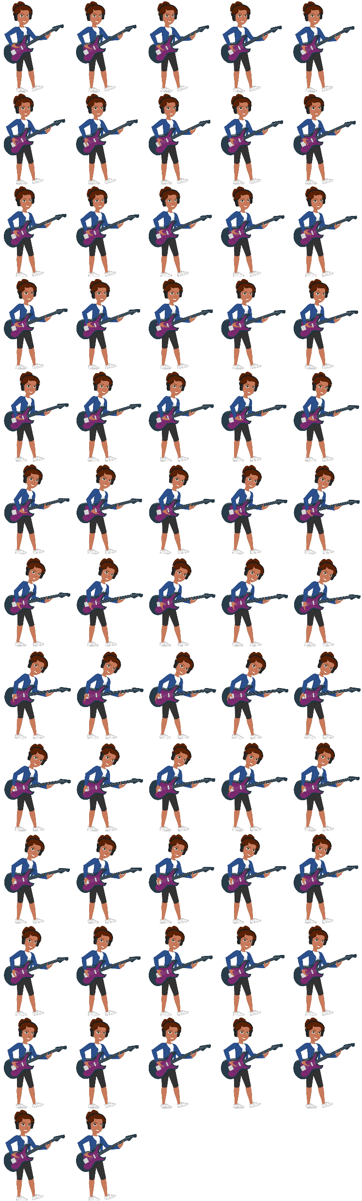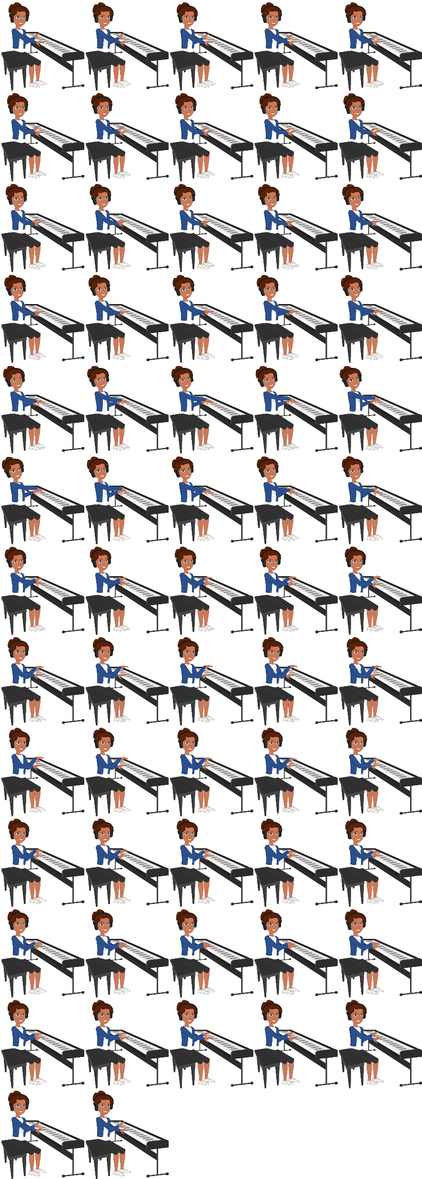

Fig 1 Part of the character sprites

1. Learning Unity3d software

* Duration: 1 month
* Learning the syntax and c# by watching youtube and enrolling to udemy classes.

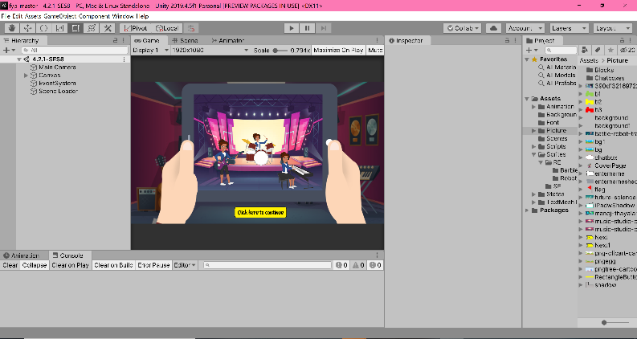

Fig 2 Unity Setups

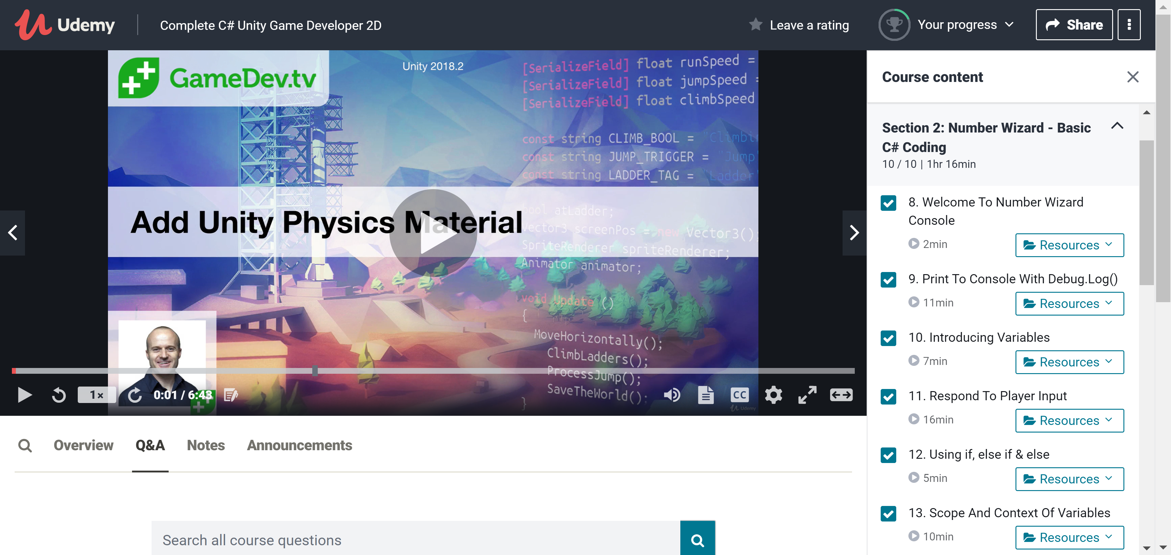

Fig 3 Udemy Classes

1. First character done (Robot Engineer)

* Duration: 3 weeks
* Created the storyline
* Laid out the background
* Logic and gameplay done

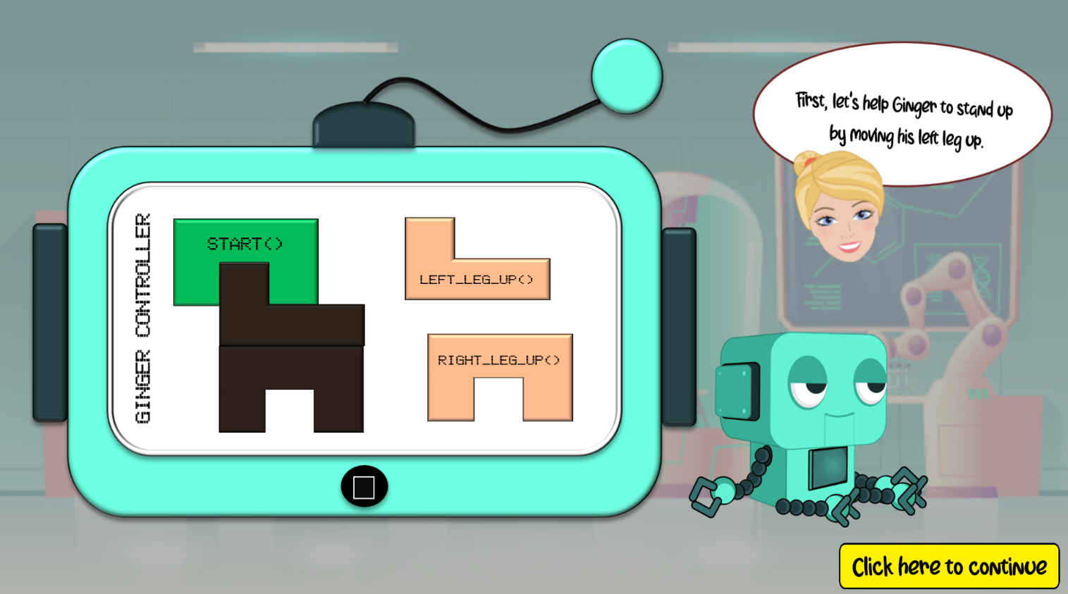

Fig 4 Part of Robot Engineer Scenes

1. In the middle of doing the second character (Sound Engineer)

* Estimated Duration: 1-1.5 months (due to other modules)
* Done with the storyline
* Laid out the background

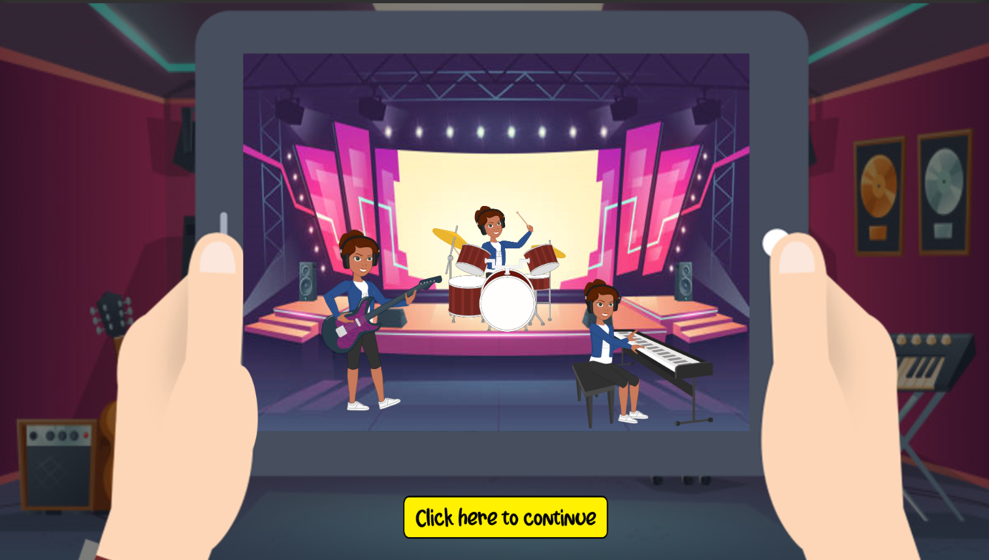

Fig 5 Part of Sound Engineer Scenes

**Future Work**

1. Finish the Sound Engineer and Computer Engineer

* Duration: 2 months

1. Try to deploy in mobile
2. If time permits, create a game focused on boys

**Conclusion**

Overall, I enjoyed the project very much. Not only it is entertaining and vibrant, but it’s also a learning tool for children, especially girls. The hard thing I face is creating the logic, storyline and being very detailed (*what if the player presses button A instead of button B*). Also, it’s hard to create your original characters. I’ve been trying to look for sprites available in the internet, however, it does not do what my game intends to portray. Hence, I created my own characters.